**BIOLOGICAL SCIENCES**

**UNIT 3 and 4 2016**



|  |  |
| --- | --- |
| **Section** | **Marks** |
| Section One: Multiple‐choice | /30 |
| Section Two: Short answer | /50 |
| Section Three: Extended answer | /20 |
|  | **/100** |

Name: _________________________________________

Teacher: _____________________________________

**Time allowed for this paper**

Reading time before commencing work: ten minutes

Working time for paper: three hours

**Materials required/recommended for this paper**

**To be provided by the supervisor**

Number of additional

answer booklets used

(if applicable):

This Question/Answer Booklet

Multiple-choice Answer Sheet

**To be provided by the candidate**

Standard items: pens (blue/black preferred), pencils (including coloured), sharpener, correction

tape/fluid, eraser, ruler, highlighters

Special items: up to three non-programmable calculators approved for use in the WACE

examinations

**Important note to candidates**

No other items may be taken into the examination room. It is your responsibility to ensure that

you do not have any unauthorised notes or other items of a non-personal nature in the

examination room. If you have any unauthorised material with you, hand it to the supervisor

before reading any further.

**Structure of this paper**

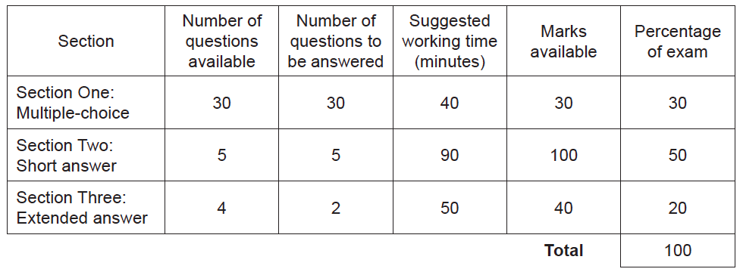

**Instructions to candidates**

1. The rules for the conduct of Western Australian external examinations are detailed in the Year 12 Information Handbook 2016. Sitting this examination implies that you agree to abide by these rules.
2. Answer the questions according to the following instructions.

**Section One**: Answer **all** questions on the separate Multiple-choice Answer Sheet provided. For each question, shade the box to indicate your answer. Use only a blue or black pen to shade the boxes. If you make a mistake, place a cross through that square, then shade your new answer. Do not erase or use correction fluid/tape. Marks will not be deducted for incorrect answers. No marks will be given if more than one answer is completed for any question.

**Sections Two and Three**: Write your answers in the spaces provided in this Question/Answer Booklet. Wherever possible, confine your answers to the line spaces provided. Use a black or blue pen (not pencil) for this section. Only the graph may be drawn in pencil.

Section Three consists of **four** questions. You must answer two questions, one from Unit 3 and one from Unit 4. Tick the box next to the question you are answering. Do not copy the questions when answering. Answers can be presented in a variety of ways: using clearly-labelled tables and graphs or diagrams with explanatory notes, writing lists of points with linking sentences or drawing annotated flow diagrams with introductory notes

3. You must be careful to confine your responses to the specific questions asked and to follow any instructions that are specific to a particular question.

**Section One: Multiple-choice 30% (30 Marks)**

This section has 30 questions. Answer all questions on the separate Multiple-choice Answer Sheet provided. For each question, shade the box to indicate your answer. Use only a blue or black pen to shade the boxes. If you make a mistake, place a cross through that square, then shade your new answer. Do not erase or use correction fluid/tape. Marks will not be deducted for incorrect answers. No marks will be given if more than one answer is completed for any question.

Suggested working time: 40 minutes.

________________________________________________________________________________

1. Which of the following cells will have a haploid nucleus?

(a) White blood cell.

(b) Root hair cell.

(c) Sperm cell.

(d) Nerve cell.

2. The enzyme responsible for unzipping the DNA double helix during replication is

(a) DNA ligase.

(b) DNA helicase.

(c) DNA polymerase.

(d) RNA polymerase.

3. In the modification of mRNA prior to leaving the nucleus, the section of the mRNA that are removed are the

(a) exons.

(b) poly-A-tails.

(c) methylated caps.

(d) introns.

4. Gene silencing is associated with

(a) DNA methylation.

(b) X - activation.

(c) gene activation.

(d) loosening of the DNA from the nucleosomes.

5. The part of the cell that assembles ribosomes is the

(a) nucleolus.

(b) rough endoplasmic reticulum.

(c) mitochondrion.

(d) Golgi apparatus.

# Questions 6 and 7 refer to the information below.

# Australia has the highest rate of mammalian decline and extinction in the world. In Western Australia, woylies were once abundant mammals but a massive decline in the woylie population coincided with the arrival of the fox between1910–1930, and only three populations remain. The impact of fox predation on woylies in two of these populations, Dryandra Woodland (DW) and Tutanning Nature Reserve has been studied. The Western Shield Fauna Recovery Program which controlled fox numbers using the 1080 baiting appeared to help to recover the woylie populations at both sites but in 2006, the numbers of woylies were again very low.

# Woylie trap success in Dryandra Woodland (continuous line) and Tutanning Nature Reserve (dotted line) from pre-1980 to 2006 (data collected by personnel from the Department of Parks and Wildlife & earlier agencies).

igure 1. Woylie trap success in Dryandra Woodland (continuous line) and Tutanning Nature Reserve (dotted line) from pre-1980 to 2006 (data collected by personnel from the Department of Parks and Wildlife and earlier agencies). 
                

<https://www.researchgate.net/figure/280093181_fig1_Figure-1-Woylie-trap-success-in-Dryandra-Woodland-continuous-line-and-Tutanning-Nature>

6. The dependent variable for this investigation is

(a) time (years).

(b) the sample sites, the Dryandra Woodland and Tutanning Nature Reserve.

(c) the percentage trap success.

(d) fox predation.

7. Which of the following could be valid reasons for the recent decline in woylies even following the successful control of fox numbers in these two areas?

I feral cats

II small population of woylies with reduced genetic diversity

III competition from greater numbers of rabbits for burrowing sites, due to less fox

predation.

(a) I, II and III

(b) I and II only.

(c) II and III only.

(d) I and III only.

# Questions 8 to 11 refer to the information below.

Chytridiomycosis, Batrachochytrium dendrobatidis (Bd) is a pathogen of amphibians that has been implicated in amphibian declines worldwide. Bd is the only member of its clade known to attack vertebrates.

8. To which group of organisms does Chytridiomycosis belong?

(a) protists

(b) fungi

(c) bacteria

(d) viruses

9. Which factor is thought to be the main cause for the spread of Chytridiomycosis worldwide?

(a) amphibian migration

(b) divergent evolution

(c) geographical isolation

(d) human activity

10. In an attempt to understand the genetic reason for Chytridiomycosis evolved from non-pathogenic ancestors, scientists mapped the genome of Chytridiomycosis and its closest relatives. Which technique did the scientists use to map the genome?

(a) gel electrophoresis

(b) DNA sequencing

(c) DNA microarrays with gene probes

(d) PCR (polymerase chain reaction)

11. Scientists mapped the genome of Chytridiomycosis (Bd) and its closest relatives. The diagram below shows some of their findings. Asp are a family of genes that code for protease enzymes that are thought to be essential for the Chytridiomycosis invading the keratinized skin cells of amphibians. The numerical value indicates the number of genes in the Asp gene family.

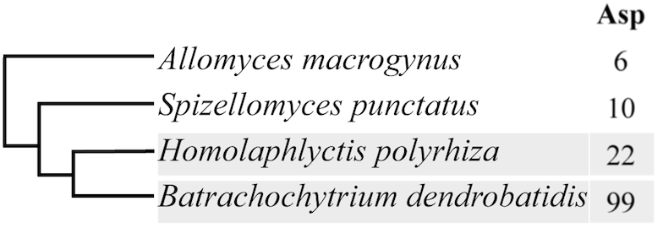

Which of the statements regarding this cladogram is correct?

1. *Allomyces macrogynus* is the closest relative of Batrachochytrium dendrobatidis.
2. Batrachochytrium dendrobatidis has more than 4 times the number of genes to code for the protease enzymes compared to their closest relative Homolaphylyctis polyrhiza.

(c) *Spizellomyces punctatus* has the lowest potential to produce protease enzymes.

(d) Batrachochytrium dendrobatidis is more closely related to *Spizellomyces punctatus* then Homolaphylyctis polyrhiza.

12. In fossil dating, relative dating is commonly used. It is also referred to as

(a) comparative dating

(b) absolute dating

(c) radiometric dating

(d) isotope dating

# Questions 13 to 14 refer to the information below.

This diagram shows a gel electrophoresis performed to determine paternity

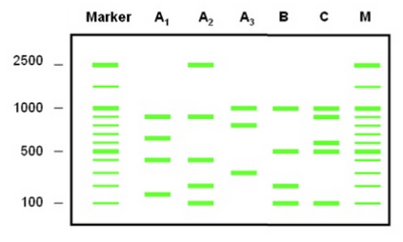

13. If individual C is the mother of B, which individual is most likely to be the father?

(a) A1

(b) A2

(c) A3

(d) neither of the individuals

14. Which value indicates the segment of DNA that has migrated the greatest distance through the gel agarose?

(a) 2500

(b) 1000

(c) 500

(d) 100

15. In the case of genetic engineering, such as the engineering of bacterial cells to produce human insulin, vectors are used. Vectors are:

* 1. bacterial cells used to manufacture the human protein.
  2. plasmids that are inserted into bacterial cells.
  3. section of insulin coding DNA, extracted from healthy human cells.
  4. viruses that are used to insert insulin DNA into bacterial cells.

16. A farmer owns a black bull, he would like to know if the genotype of the bull is heterozygous or homozygous dominant. Black is the dominant allele for the colour of cattle. To determine the bulls genotype, he should do a test cross by breeding the bull with a cow with the genotype

(a) BB

(b) bb

(c) Bb

(d) brown

17. Different animals maintain their body temperatures in a variety of ways. Which of the following best describes an animal that is an **ectotherm**?

(a) An emu living in the Simpson Desert.

(b) A tuna that can dive to great depths.

(c) A polar bear hibernating over the winter months.

(d) A green tree frog living in a temperate forest.

18. The capacity of a disease to cause severe disease within its host is referred to as its

(a) infectivity

(b) virulence

(c) outbreak

(d) pandemic

19. Which of the following homeostatic activities represent negative-feedback mechanisms?

(a) Labour, fever and gas-exchange.

(b) Water balance, gas-exchange and thermoregulation.

(c) Blood-glucose levels, thermoregulation and fever.

(d) Fever, lactation and water balance.

20. The Phylum Oomycota containing *Phytophthora* (dieback) belongs to the Kingdom

(a) Fungi

(b) Eubacteria

(c) Archaebacteria

(d) Protista

21 The feature of prions that distinguishes them from all other types of pathogens is they

(a) do not contain RNA or DNA

(b) are not cells

(c) cannot reproduce outside a host cell

(d) infect brain and nervous tissue

22. Some schools will send out letters to inform the community if there has been a reported case of chicken pox amongst the students.

The infected student would experience:

* mild fever
* headache
* runny nose and cough.
* a rash

How would you classify these descriptions?

(a) Symptoms

(b) Methods of transmission

(c) Causes

(d) Warnings

23. A disease that is caused by a bacterium is

(a) influenza

(b) chytridiomycosis

(c) tuberculosis

(d) malaria

24. A zoonotic disease is best described as a disease that

(a) has only been found within the confines of a zoo.

(b) requires a host to complete its lifecycle.

(c) only affects organisms within Kingdom Animalia.

(d) can be transmitted between animals and humans.

25. The following diagram represents a nephron from a human kidney.

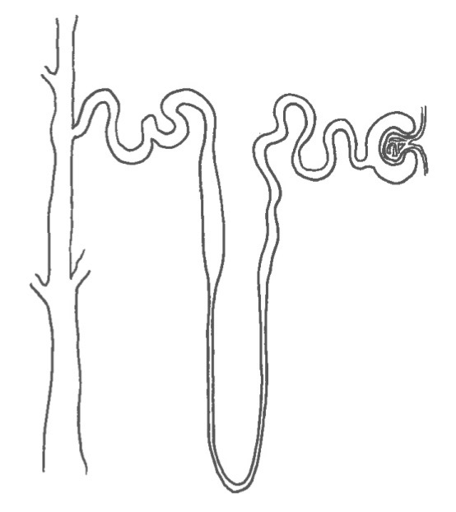

Which of the following statements correctly describes how the nephron of a desert marsupial is different?

(a) The loop of Henle is very long to increase the reabsorption of water.

(b) The glomerulus is smaller to decrease the amount of fluid entering the Bowman’s capsule.

(c) The loop of Henle is much shorter to stop sodium and urea from being lost in the urine.

(d) The distal convoluted tubule is reduced in order reduce amount of water reabsorbed.

Questions continued on next page

Questions 26 and 27 refer to the following graph.

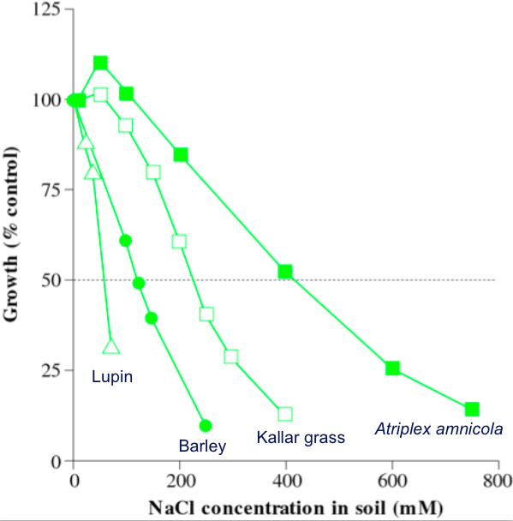

**Graph showing the growth of four contrasting species over a range of saline conditions.**

(after http://plantsinaction.science.uq.edu.au/edition1/?q=content/17-2-1-annual-plants)

26. Which species would be considered to be the most well adapted halophyte?

(a) Lupin

(b) Barley

(c) Kallar grass

(d) *Atriplex amnicola*

27. The lowest % growth was recorded for Barley when the NaCl concentration in the soil was

(a) 600 mM

(b) 400 mM

(c) 250 mM

(d) 100 mM

28. The photo shows large termite (insect) mounds in the Northern Territory. The termites build these mounds with a narrow side facing the midday sun and the wide sides facing towards the morning and late afternoon sun.

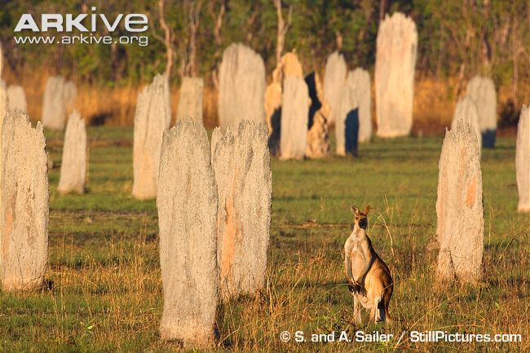

Termite mounds

The structure of these mounds helps the termites to

1. remain cool in the early mornings
2. become endothermic
3. maintain a relatively constant body temperature
4. produce enzymes that work efficiently at hot temperatures.

29. A fungus *Phythopthera* which lives in the soil is killing the Wollemi Pine (*Wollemia nobilis*) in NSW. Scientists have discovered a small and remote uninfected population of pines in the Blue Mountains of NSW. Which procedure would be most effective in preventing the spread of the fungus this Wollemi pine population?

1. Prevent the importation of Wollemi pines into WA.
2. Export the Wollemi pines to Asia
3. Quarantine the Wollemi pines that are being imported into Australia
4. Washing all the soil from the scientist and other visitors shoes before they walk into remote area

30. In order to maintain water balance and reduce energy consumption, reptiles excrete nitrogenous waste in the form of

(a) ammonia.

(b) urine.

(c) guano.

(d) uric acid.

**End of Section One**

**Section Two: Short answer 50% (100 Marks)**

This section has **five (5)** questions. Answer **all** questions. Write your answers in the spaces

provided in this Question/Answer Booklet. Wherever possible, confine your answers to the

line spaces provided. Use a blue or black pen for this section. Only the graph may be drawn in

pencil.

Spare pages are included at the end of this booklet. They can be used for planning your

responses and/or as additional space if required to continue an answer.

* Planning: If you use the spare pages for planning, indicate this clearly at the top of the page.
* Continuing an answer: If you need to use the space to continue an answer, indicate in the

original answer space where the answer is continued, i.e. give the page number. Fill in the number of the question that you are continuing to answer at the top of the page.

Suggested working time: 90 minutes.

**________________________________________________________________________________**

**Question 31 (15 marks)**

Melanin is the natural pigment that is responsible for our hair and skin colour. Cells called melanocytes that are found in mammalian skin produce melanin. A special protein (enzyme), called tyrosinase enables melanin production.

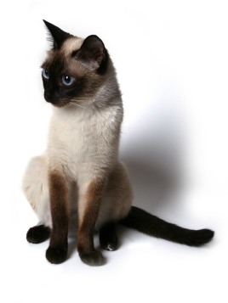

Scientists found that Siamese cats have a

mutation in the gene that codes for tyrosinase,

making it temperature-sensitive. Increasing

the temperature decreases the activity of the

tyrosinase, so less melanin is produced.

1. The TRY gene codes for the production of the protein enzyme tyrosinase in melanocytes. State the two main steps in protein production. (2 marks)
2. ______________________________________________________
3. ______________________________________________________
4. Describe the formation of mRNA from the DNA template. (4 marks)

__________________________________________________________________________

__________________________________________________________________________

__________________________________________________________________________

__________________________________________________________________________

__________________________________________________________________________

__________________________________________________________________________

__________________________________________________________________________

__________________________________________________________________________

__________________________________________________________________________

1. The image below shows a structure found in cells. Briefly discuss its role in the second step of protein synthesis. (3 marks)

|  |  |
| --- | --- |
| **Structure** | **Role in protein synthesis** |
|  | ____________________________________________________  ____________________________________________________  ____________________________________________________  ____________________________________________________  ____________________________________________________  ____________________________________________________  ____________________________________________________  ____________________________________________________  ____________________________________________________  ____________________________________________________ |

1. Referring to the temperature sensitive enzyme tyrosinase, provide a scientific explanation for the colouration patterns observed in Siamese cats. (3 marks)

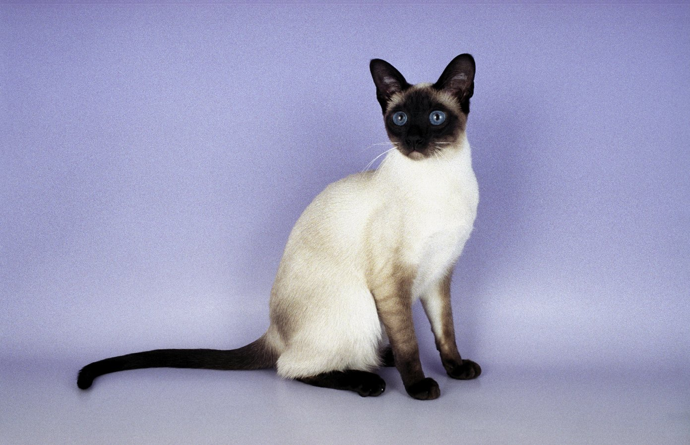

__________________________________________________________________________

__________________________________________________________________________

__________________________________________________________________________

__________________________________________________________________________

1. Describe how counter-current heat exchange mechanisms are used by ectotherms that live in cold environments to reduce heat loss. (3 marks)

__________________________________________________________________________

__________________________________________________________________________

__________________________________________________________________________

__________________________________________________________________________

**Question 32 (10 marks)**

Animals are generally described as being endothermic (homeothermic) or ectothermic (poikilothermic).

1. Differentiate between endothermic and ectothermic animals. (2 marks)

__________________________________________________________________________

__________________________________________________________________________

__________________________________________________________________________

Daily and prolonged torpor (temporary hibernation) in many Australian mammals appear to be opportunistic and not only important for survival of adverse seasonal conditions, but apparently also for dealing with unpredictable events such as droughts and perhaps fires and floods. During torpor these animals are able to decrease their body temperatures by up to 10oC. These animals are therefore said to be ‘heterothermic’.

The graph below shows the known or estimated number of heterothermic species/all species of Australian terrestrial mammals

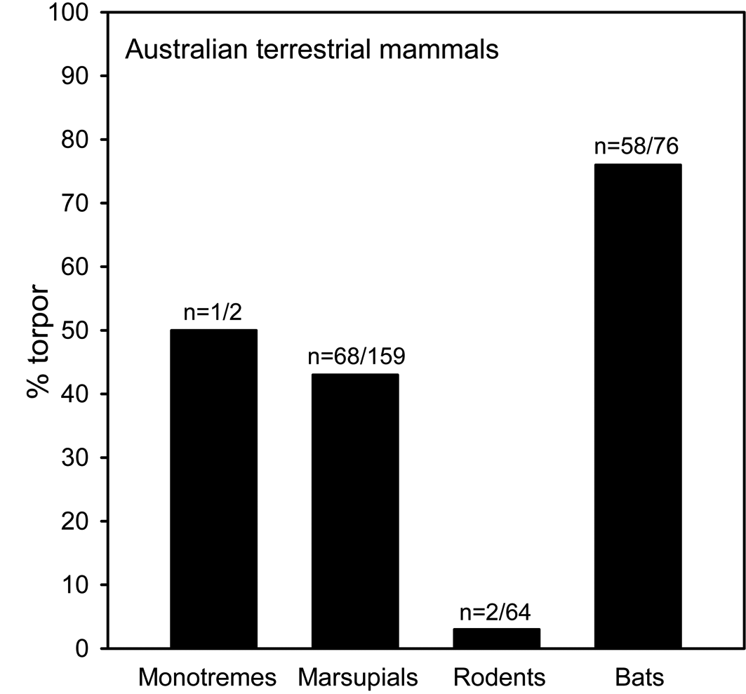

1. Calculate the percentage of marsupials that are heterothermic. (2 marks)
2. Which group of Australian mammals has the highest percentage of heterotherms? (1 mark)

__________________________________________________________________________

1. Explain how torpor helps to reduce the energy needs of the animals. (2 mark)

__________________________________________________________________________

__________________________________________________________________________

__________________________________________________________________________

1. Scientific studies have shown that none of the heterothermic Australian species has gone extinct. In contrast many of the similar-sized homeothermic species, such as rodents and bandicoots, have suffered high rates of extinction. Discuss how torpor helps to improve the survival rate of Australian animals. (3 marks)

__________________________________________________________________________

__________________________________________________________________________

__________________________________________________________________________

__________________________________________________________________________

__________________________________________________________________________

**Question 33 (15 marks)**

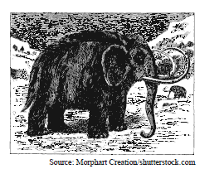

The extinct woolly mammoth, *Mammuthus primigenius*, was closely related and similar in size to

present-day elephants. It was herbivorous and highly adapted to very cold climates, with a dense undercoat and small, fur-lined ears. The table below shows information about woolly mammoths inferred from extensive fossil evidence.

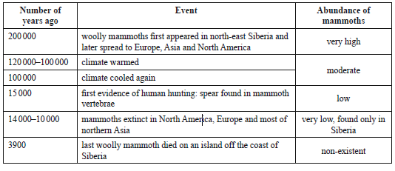

(a)Define the term ‘selection pressure’ and, based on the information provided, give an example of a

selection pressure on woolly mammoths. (2 marks)

____________________________________________________________________________________________________________________________________________________________________________________________________________________________________________________________________________________

ii.Suggest how it could be possible for *M. primigenius* to have arisen so recently (0.2 mya) yet now

be extinct, while the Asiatic elephant, *E. maximus*, has been present for over 6 million years.

(2 marks)

_______________________________________________________________________________________________________________________________________________________________________________________________________________

It has been suggested that elephant-like ancestors of the woolly mammoth left Africa 3.5 million years

ago (mya) and lived in Central Europe. The chart below shows a summarised phylogenetic tree based on mitochondrial and chromosomal DNA from fossils and living elephants.

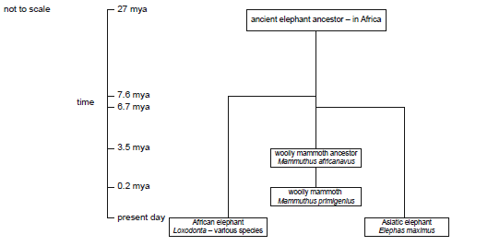

(b) Explain how the woolly mammoth *M. primigenius* probably arose from the woolly mammoth

ancestor *M. africanavus. (*3 marks)

____________________________________________________________________________________________________________________________________________________________________________________________________________________________________________________________________________________

**________________________________________________________________________________________________________________________________________________________________**

(c) A small amount of well-preserved DNA was extracted from a frozen woolly mammoth fossil. Explain how scientists could firstly increase the amount of DNA available for study in the lab, and how DNA hybridization could be used to compare the DNA of the two elephants. (8 marks)

____________________________________________________________________________________________________________________________________________________________________________________________________________________________________________________________________________________

____________________________________________________________________________________________________________________________________________________________________________________________________________________________________________________________________________________

____________________________________________________________________________________________________________________________________________________________________________________________________________________________________________________________________________________

____________________________________________________________________________________________________________________________________________________________________________________________________________________________________________________________________________________

**Question 34 (20 marks)**

The Rio Olympics 2016 has led to much publicity regarding the Zika virus. Zika virus infection is generally a non-severe viral illness transmitted by the bite of an infected Aedes mosquitoe. Due to an outbreak which started in Brazil in 2015, the World Health Organization declared it a Public Health Emergency of International Concern in February 2016. Scientific evidence shows that a Zika virus infection in a pregnant woman can be transmitted to the foetus, and can cause certain birth abnormalities (including microcephaly – under developed brain). Multiple instances of sexual transmission have now been reported, involving a symptomatic man transmitting theZika virus to a woman.

(a) Identify the two mechanisms of transmission of the Zika virus. (2 marks)

1. ______________________________________________________
2. ______________________________________________________

(b) Explain why the term ‘outbreak’ is used regarding the Zika virus in Brazil. (1 mark)

__________________________________________________________________________

(c) Why is the Zika virus referred to as a contagious pathogen? (2 marks)

__________________________________________________________________________

__________________________________________________________________________

__________________________________________________________________________

(d) Several sources have observed that there is a very small risk that athletes or spectators travelling to the Rio Olympics will contract Zika because it is not mosquito season. However, what advice would you give a person travelling to Rio in August to help reduce their risk of contracting Zika? (4 marks)

__________________________________________________________________________

__________________________________________________________________________

__________________________________________________________________________

__________________________________________________________________________

__________________________________________________________________________

__________________________________________________________________________

(e) Explain why viruses are said to be obligate parasites. (2 marks)

_________________________________________________________________________

__________________________________________________________________________

(f) Results from recent studies on the Zika virus show that they infect the cells of the skin and developing nerve cells. The virus destroys cells as it replicates, leading to cellular apoptosis and in this way boosts spreading of this pathogenic agent.

1. Define the term cell apoptosis (2 marks)

___________________________________________________________________________

___________________________________________________________________________

1. Using your knowledge of the reproduction of viruses, use annotated diagrams to show how the Zika virus would infect a cell. (5 marks)

(g) List two differences between the malaria and Zika, both pathogens transmitted by mosquitos. (2 marks)

|  |  |  |
| --- | --- | --- |
|  | Malaria | Zika |
| Difference 1 |  |  |
| Difference 2 |  |  |

**Question 35 (20 marks)**

Phenylketonuria is a rare metabolic disorder that affects the way the body breaks down protein. If not treated shortly after birth, PKU can be destructive to the nervous system, causing intellectual disability. PKU is caused by a mutation in a gene on chromosome 12. It is an autosomal recessive disorder.

(a). Explain the implications of PKU being due to a germ-line mutation. (2 marks)

___________________________________________________________________________

___________________________________________________________________________

(b) What is the meaning of PKU being described as an autosomal recessive disorder?

(2 marks)

___________________________________________________________________________

___________________________________________________________________________

(c) A couple decide to have a child. Genetic tests show that they are both heterozygous for PKU. Give the genotypes of the couple and use a Punnett square to show the percentage chance that the child will have PKU. Use the symbol ‘t’ to represent the mutated gene. (5 marks)

(d) Over 400 different gene mutations have been identified in the defective gene that results in PKU, including silent mutations.

(i) What is a silent mutation? (1 mark)

______________________________________________________________________

______________________________________________________________________

(ii) Differentiate between an insertion and a deletion mutation. (2 marks)

______________________________________________________________________

______________________________________________________________________

(iii) Explain why insertion and deletion mutations are referred to a ‘frameshift’ mutations. (2 marks)

______________________________________________________________________

______________________________________________________________________

______________________________________________________________________

(iv) What consequence do ‘frameshift’ mutations have on protein structure?. (1 mark)

______________________________________________________________________

______________________________________________________________________

(v) Differentiate between a missense and a nonsense mutation. (2 marks)

______________________________________________________________________

______________________________________________________________________

______________________________________________________________________

______________________________________________________________________

______________________________________________________________________

(e) PKU sufferers have a gene mutation which prevents the formation on an enzyme which converts the amino acid phenylalanine into the amino acid tyrosine. Tyrosine is essential in the formation of a healthy nervous system. The graphs below show the blood serum levels of these two amino acids.

(After: Biology workbook 2 – Heinemann)

Graph A Graph B

1. Identify which graph shows the blood serum results for a PKU sufferer. (1 mark)

______________________________________________________________________

1. Give a reason for your answer to question 35 (e)(i). (2 marks)

______________________________________________________________________

______________________________________________________________________

______________________________________________________________________

**Question 36 (20 marks)**

The way in which pathogens are transmitted from one host to another can significantly impact how easily it can spread.

(a) Identify two human behaviours that can reduce the risk of contracting or spreading a contagious disease. (2 marks)

______________________________________________________________________

______________________________________________________________________

­­­­­­­­­­­______________________________________________________________________

(b) Explain why a pathogen, showing latent infection, can have a high degree of infectivity. (2 marks)

______________________________________________________________________

______________________________________________________________________

___________________________________________________________________________

(c) Differentiate between the terms endemic, epidemic and pandemic. (3 marks)

______________________________________________________________________

______________________________________________________________________

______________________________________________________________________

______________________________________________________________________

______________________________________________________________________

The development of vaccines has enabled highly contagious diseases to be eradicated from the global population.

(d) Describe how immunisation programs have been successful in stopping the spread of virulent pathogens. (2 marks)

______________________________________________________________________

______________________________________________________________________

______________________________________________________________________

(e) Explain the concept of ‘herd immunity’. (2 marks)

______________________________________________________________________

______________________________________________________________________

______________________________________________________________________

(f) Explain why herd immunity has been compromised in some communities around Australia. (2 marks)

______________________________________________________________________

______________________________________________________________________

___________________________________________________________________________

Bacteria are the most abundant and diverse group of organisms on the planet. Much of their success can be attributed to adaptations and transmission.

(g) Identify two adaptive characteristics of bacteria and explain how these characteristics increase a bacteria’s chance of survival. (4 marks) ______________________________________________________________________

______________________________________________________________________

______________________________________________________________________

______________________________________________________________________

______________________________________________________________________

______________________________________________________________________

(h) Outline three different ways in which bacteria cause disease. (3 marks)

______________________________________________________________________

______________________________________________________________________

______________________________________________________________________

______________________________________________________________________

**End of Section 2**

**Section Three: Extended answer 20% (40 Marks)**

Section Three consists of four questions.

Questions 36 and 37 are from Unit 3. Questions 38 and 39 are from Unit 4. Answer **one** question

from Unit 3 and **one** question from Unit 4.

Use black or blue pen or ballpoint for written answers and pencil for diagrams. Crossing out of incorrect material is acceptable and preferable to using correction fluid/tape.

Spare pages are included at the end of this booklet. They can be used for planning your responses and/or as additional space if required to continue an answer.

* Planning: if you use the spare pages for planning, indicate clearly at the top of the page.
* Continuing an answer: if you need to use the space to continue an answer, indicate in the original answer space where the answer is continued, i.e. give the page number. Fill in the number of the question that you are continuing to answer at the top of the page.

Suggested working time: 50 minutes.

________________________________________________________________________________________________________________________

**Unit 3: Choose either Question 37 or Question 38. (20 marks)**

**Indicate the question you will answer by ticking the box next to the question. Write your answers on pages 30 – 32. When you have answered your first question, turn to page XX and indicate the second question you will answer on that page.**

**Question 37**

During mitosis and meiosis it is important that the cells duplicate the DNA genetic material exactly to ensure that the genetic material is correctly passed onto the daughter cells.

**(a) Describe the semi-conservative process of DNA replication. (10 marks)**

Following meiosis, gametes are formed. These gametes contain the genes that will be inherited by the next generation.

**(b) One of the types of inheritance is known as sex-linked inheritance. Explain this type of inheritance, providing at least one example. (10 marks)**

**Question 38**

The Theory of Evolution as first proposed by Darwin and Wallace in 1859. The study of comparative anatomy provides interesting insights into evolutionary relationships.

1. **Explain how comparative anatomy provides evidence of evolution. (10 marks)**

Through scientific investigation and observation, scientists have shown that different types of selection drive the evolutionary process.

**(b) Discuss the differences between natural selection and sexual selection as driving mechanisms for evolution. (10 marks)**

**________________________________________________________________________**

**________________________________________________________________________**

**________________________________________________________________________**

**________________________________________________________________________**

**________________________________________________________________________**

**________________________________________________________________________**

**________________________________________________________________________**

**________________________________________________________________________**

**________________________________________________________________________**

**________________________________________________________________________**

**________________________________________________________________________**

**________________________________________________________________________**

**________________________________________________________________________**

**________________________________________________________________________**

**________________________________________________________________________**

**________________________________________________________________________**

**________________________________________________________________________**

**________________________________________________________________________**

**________________________________________________________________________**

**________________________________________________________________________**

**________________________________________________________________________**

**________________________________________________________________________**

**________________________________________________________________________**

**________________________________________________________________________**

**________________________________________________________________________**

**________________________________________________________________________**

**________________________________________________________________________**

**________________________________________________________________________**

**________________________________________________________________________**

**________________________________________________________________________**

**________________________________________________________________________**

**________________________________________________________________________**

**________________________________________________________________________**

**________________________________________________________________________**

**________________________________________________________________________**

**________________________________________________________________________**

**________________________________________________________________________**

**________________________________________________________________________**

**________________________________________________________________________**

**________________________________________________________________________**

**________________________________________________________________________**

**________________________________________________________________________**

**________________________________________________________________________**

**________________________________________________________________________**

**________________________________________________________________________**

**________________________________________________________________________**

**________________________________________________________________________**

**________________________________________________________________________**

**________________________________________________________________________**

**________________________________________________________________________**

**________________________________________________________________________**

**________________________________________________________________________**

**________________________________________________________________________**

**________________________________________________________________________**

**________________________________________________________________________**

**________________________________________________________________________**

**________________________________________________________________________**

**________________________________________________________________________**

**________________________________________________________________________**

**________________________________________________________________________**

**________________________________________________________________________**

**________________________________________________________________________**

**________________________________________________________________________**

**________________________________________________________________________**

**________________________________________________________________________**

**________________________________________________________________________**

**________________________________________________________________________**

**________________________________________________________________________**

**________________________________________________________________________**

**________________________________________________________________________**

**________________________________________________________________________**

**________________________________________________________________________**

**Unit 4: Choose either Question 38 or Question 39. (20 marks)**

**Indicate the question you will answer by ticking the box next to the question. Write your answer on the pages provided.**

**Question 39**

Mallee is an Aboriginal name for a type of vegetation community in which the eucalypts grow. The Mallee Shrublands grow in semi-arid regions. Winter in these areas is short, cool and at times quite wet, whereas the summer is long, hot and dry.

1. **Describe the adaptations that the leaves of the vegetation in Mallee Shrublands would have to help the plants survive the hot, dry summers. (10 marks)**

Australian Bat lyssavirus (ABLV) is one of twelve types of lyssavirus found worldwide. ABVL is the only type of lyssavirus found in Australia. Infection causes serious illness and death in humans.

**(b) Explain how Australian Bat lyssavirus is transmitted from bat to human. Outline the signs of infection, possible treatments and preventative measures currently used in Australia. (10 marks)**

**Question 40**

For thousands of years, viral infections have caused the death of billions of people worldwide. The nature of viruses has made the development of effective treatments both difficult and time consuming.

**(a) Describe the structure of a virus and its method of reproduction. Including a simple, labelled diagram to show the reproductive process. (10 marks)**

The barramundi is an iconic fish of Western Australia’s Kimberley region. The barramundi’s lifecycle includes freshwater, estuarine and marine phases. Their eggs hatch in the estuary, the juvenile fish then migrate into rivers and freshwater billabongs and when the fish become sexually mature (at three to five years of age) they migrate back to the saltwater.

1. **Barramundi have well developed physiological mechanisms for the regulation of salt to allow them to survive in salt and freshwater. Discuss how these mechanisms adapt as the Barramundi move from fresh water into salt water. (10 marks)**

**________________________________________________________________________**

**________________________________________________________________________**

**________________________________________________________________________**

**________________________________________________________________________**

**________________________________________________________________________**

**________________________________________________________________________**

**________________________________________________________________________**

**________________________________________________________________________**

**________________________________________________________________________**

**________________________________________________________________________**

**________________________________________________________________________**

**________________________________________________________________________**

**________________________________________________________________________**

**________________________________________________________________________**

**________________________________________________________________________**

**________________________________________________________________________**

**________________________________________________________________________**

**________________________________________________________________________**

**________________________________________________________________________**

**________________________________________________________________________**

**________________________________________________________________________**

**________________________________________________________________________**

**________________________________________________________________________**

**________________________________________________________________________**

**________________________________________________________________________**

**________________________________________________________________________**

**________________________________________________________________________**

**________________________________________________________________________**

**________________________________________________________________________**

**________________________________________________________________________**

**________________________________________________________________________**

**________________________________________________________________________**

**________________________________________________________________________**

**________________________________________________________________________**

**________________________________________________________________________**

**________________________________________________________________________**

**________________________________________________________________________**

**________________________________________________________________________**

**________________________________________________________________________**

**________________________________________________________________________**

**________________________________________________________________________**

**________________________________________________________________________**

**________________________________________________________________________**

**________________________________________________________________________**

**________________________________________________________________________**

**________________________________________________________________________**

**________________________________________________________________________**

**________________________________________________________________________**

**________________________________________________________________________**

**________________________________________________________________________**

**________________________________________________________________________**

**________________________________________________________________________**

**________________________________________________________________________**

**________________________________________________________________________**

**________________________________________________________________________**

**________________________________________________________________________**

**________________________________________________________________________**

**________________________________________________________________________**

**________________________________________________________________________**

**________________________________________________________________________**

**________________________________________________________________________**

**________________________________________________________________________**

**________________________________________________________________________**

**________________________________________________________________________**

**________________________________________________________________________**

**________________________________________________________________________**

**________________________________________________________________________**

**________________________________________________________________________**

**________________________________________________________________________**

**________________________________________________________________________**

**________________________________________________________________________**

**________________________________________________________________________**